# MIS 275 - Lab 3

You will need to complete this lab by using SQL Server Management Studio. Use your textbook, in class activity and lecture as resources for help in completing the lab. Once you have completed the assignment then upload it to Canvas. Save your document with the following naming convention:

* Course_Lab Number_First Initial Last Name (Example: MIS275_Lab3_LStewart.docx)

My Guitar Shop Exercises

In these exercises, you’ll use SQL Server Management Studio and the MyGuitarShop database to enter SQL statements and run them against this database.

Enter and run SELECT statements

In these activities, you’ll enter and run your own SELECT statements. In addition to providing screen prints, create a SQL script file that contains your SQL statements for the 7 exercises below. Once you’ve completed this lab, zip this Word document with your answers and your script file and upload the zipped file to the designated link in Canvas.

1. Write a SELECT statement that returns four columns from the Products table: ProductCode, ProductName, ListPrice, and DiscountPercent. Then, run this statement to make sure it works correctly.

Add an ORDER BY clause to this statement that sorts the result set by list price in descending sequence. Then, run this statement again to make sure it works correctly. This is a good way to build and test a statement, one clause at a time.

Paste a screen print of the SQL statement and the resulting data set below.

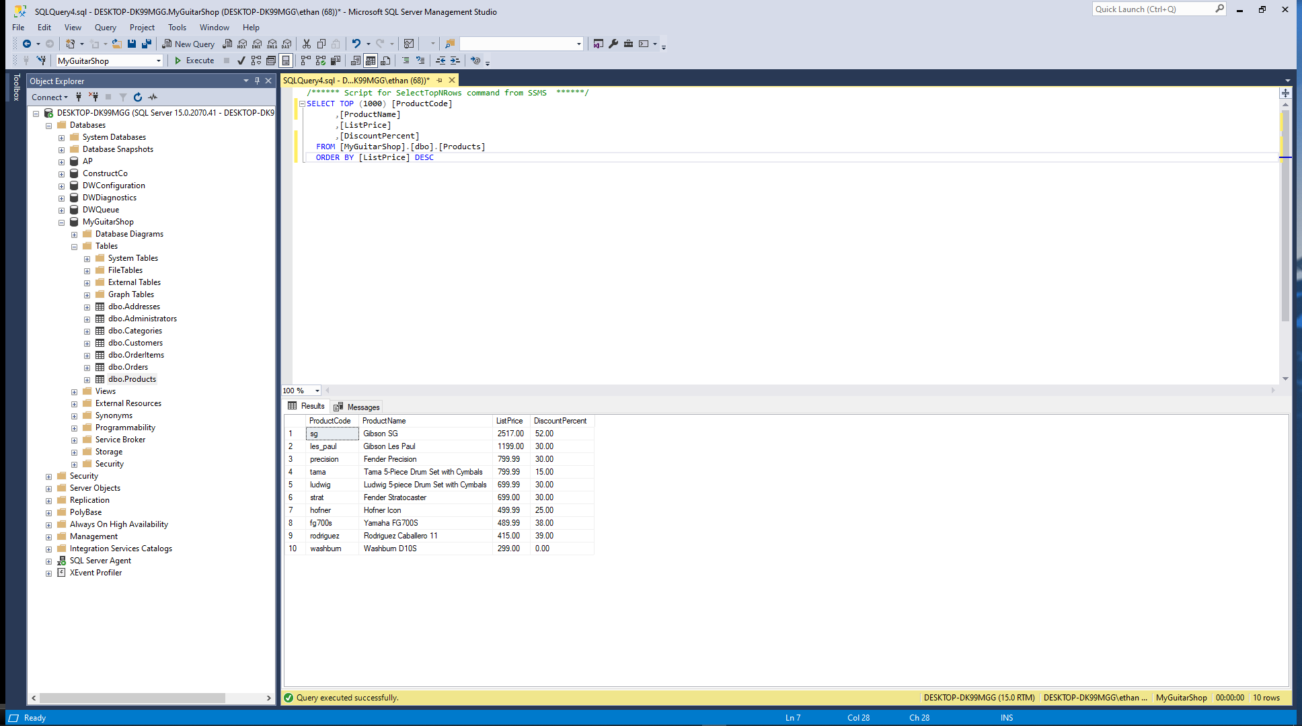

1. Write a SELECT statement that returns one column from the Customers table named FullName that joins the LastName and FirstName columns.

Format this column with the last name, a comma, a space, and the first name like this:

Doe, John

Sort the result set by last name in ascending sequence.

Return only the contacts whose last name begins with letters from M to Z.

Paste a screen print of the SQL statement and the resulting data set below.

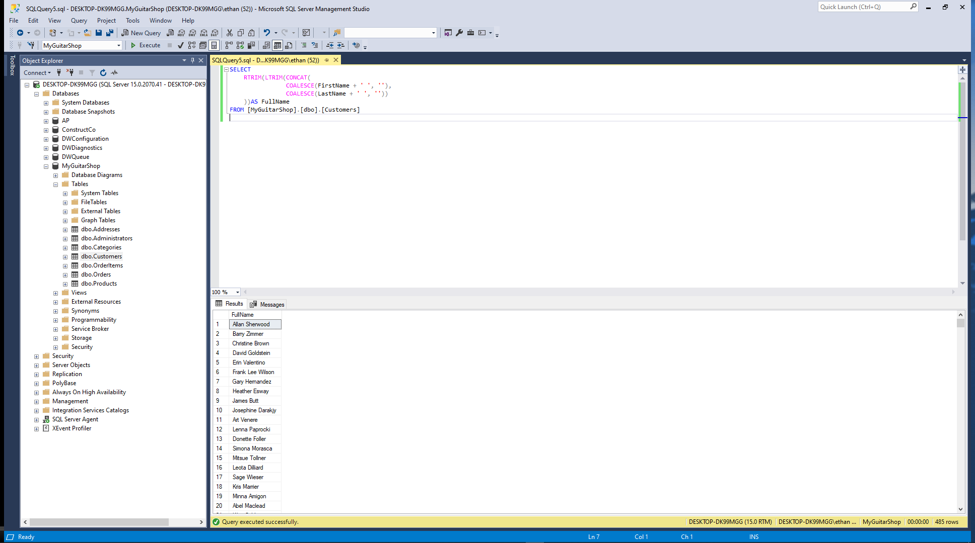

1. Write a SELECT statement that returns these column names and data from the Products table:

ProductName The ProductName column

ListPrice The ListPrice column

DateAdded The DateAdded column

Return only the rows with a list price that’s greater than 500 and less than 2000.

Sort the result set in descending sequence by the DateAdded column.

Paste a screen print of the SQL statement and the resulting data set below.

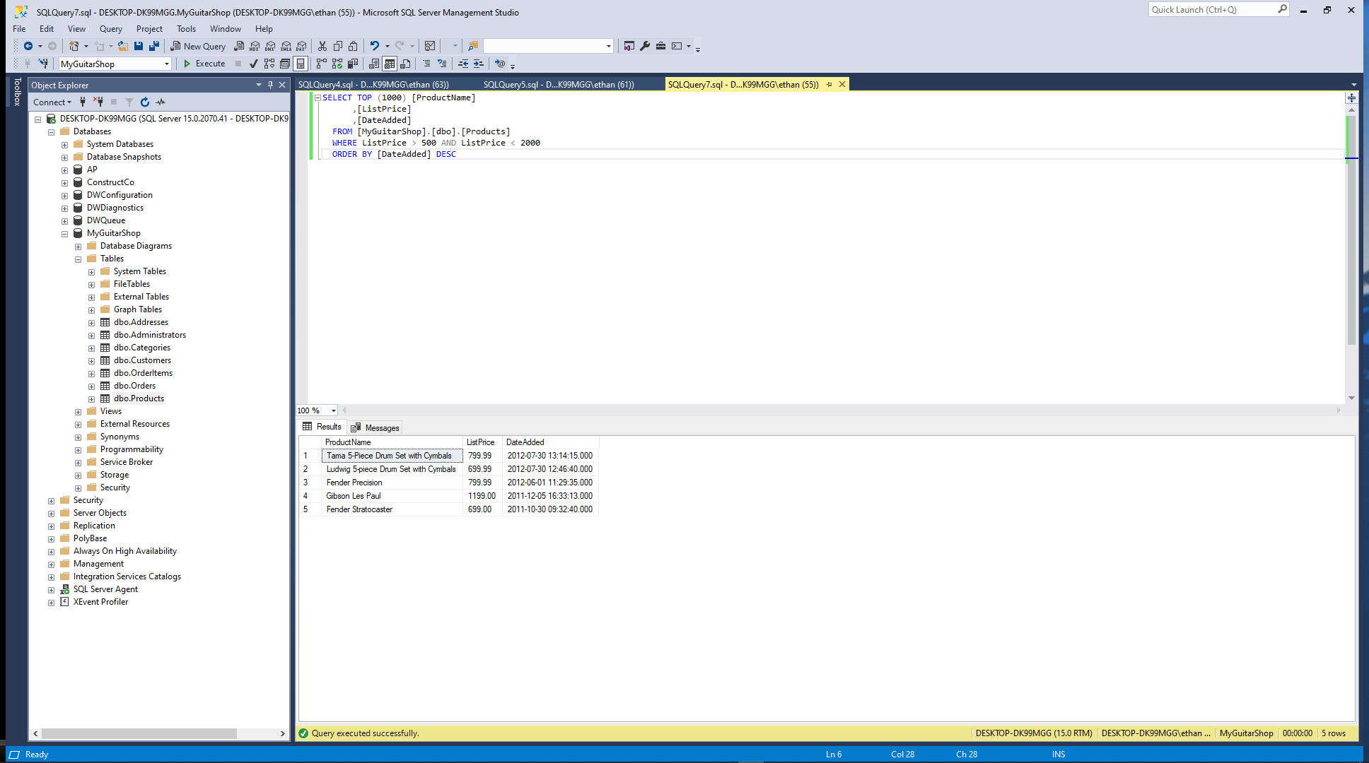

1. Write a SELECT statement that returns these column names and data from the Products table:

ProductName The ProductName column

ListPrice The ListPrice column

DiscountPercent The DiscountPercent column

DiscountAmount A column that’s calculated from the previous two columns

DiscountPrice A column that’s calculated from the previous three columns

Sort the result set by discount price in descending sequence.

Paste a screen print of the SQL statement and the resulting data set below.

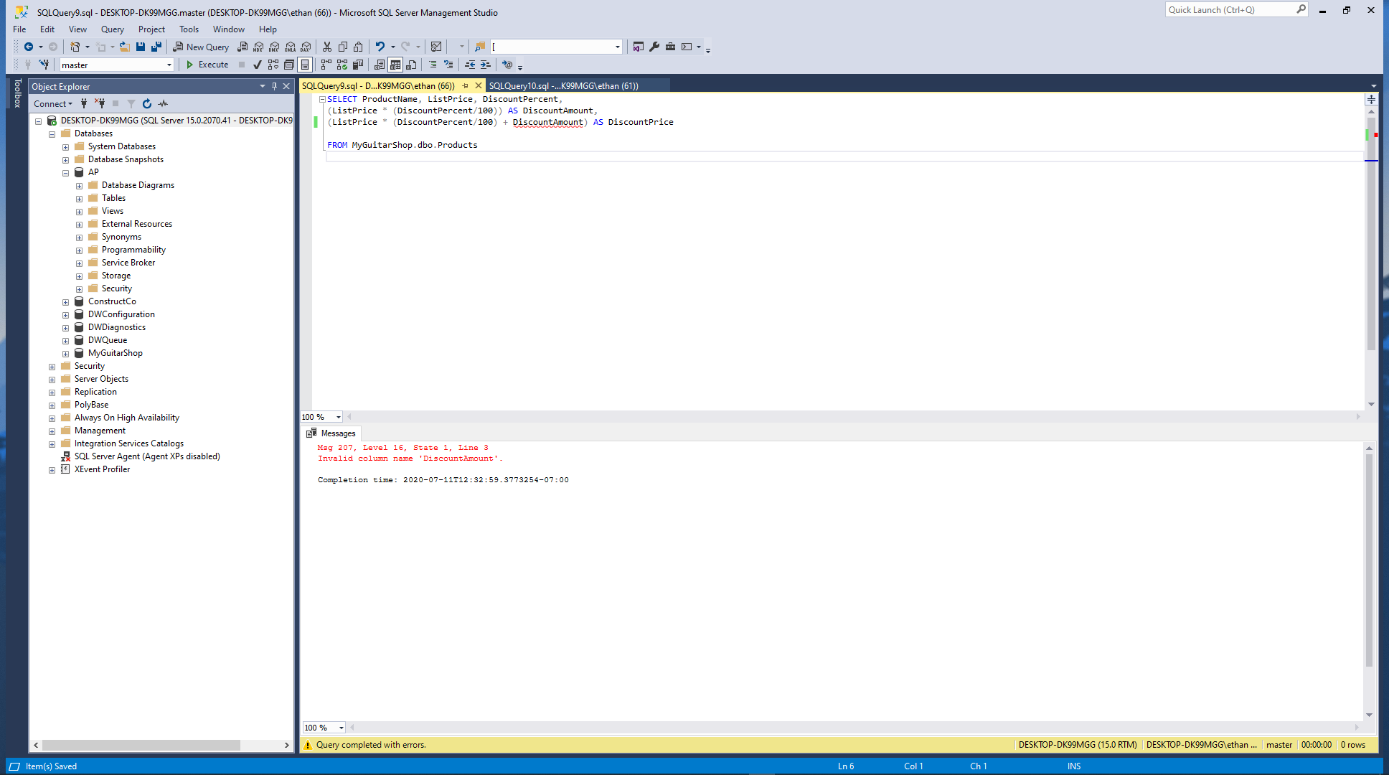

CANT GET IT TO WORK

1. Write a SELECT statement that returns these column names and data from the OrderItems table:

ItemID The ItemID column

ItemPrice The ItemPrice column

DiscountAmount The DiscountAmount column

Quantity The Quantity column

PriceTotal A column that’s calculated by multiplying the item price with the quantity

DiscountTotal A column that’s calculated by multiplying the discount amount with the quantity

ItemTotal A column that’s calculated by subtracting the discount amount from the item price and then multiplying by the quantity

Only return rows where the ItemTotal is greater than 500.

Sort the result set by item total in descending sequence.

Paste a screen print of the SQL statement and the resulting data set below.

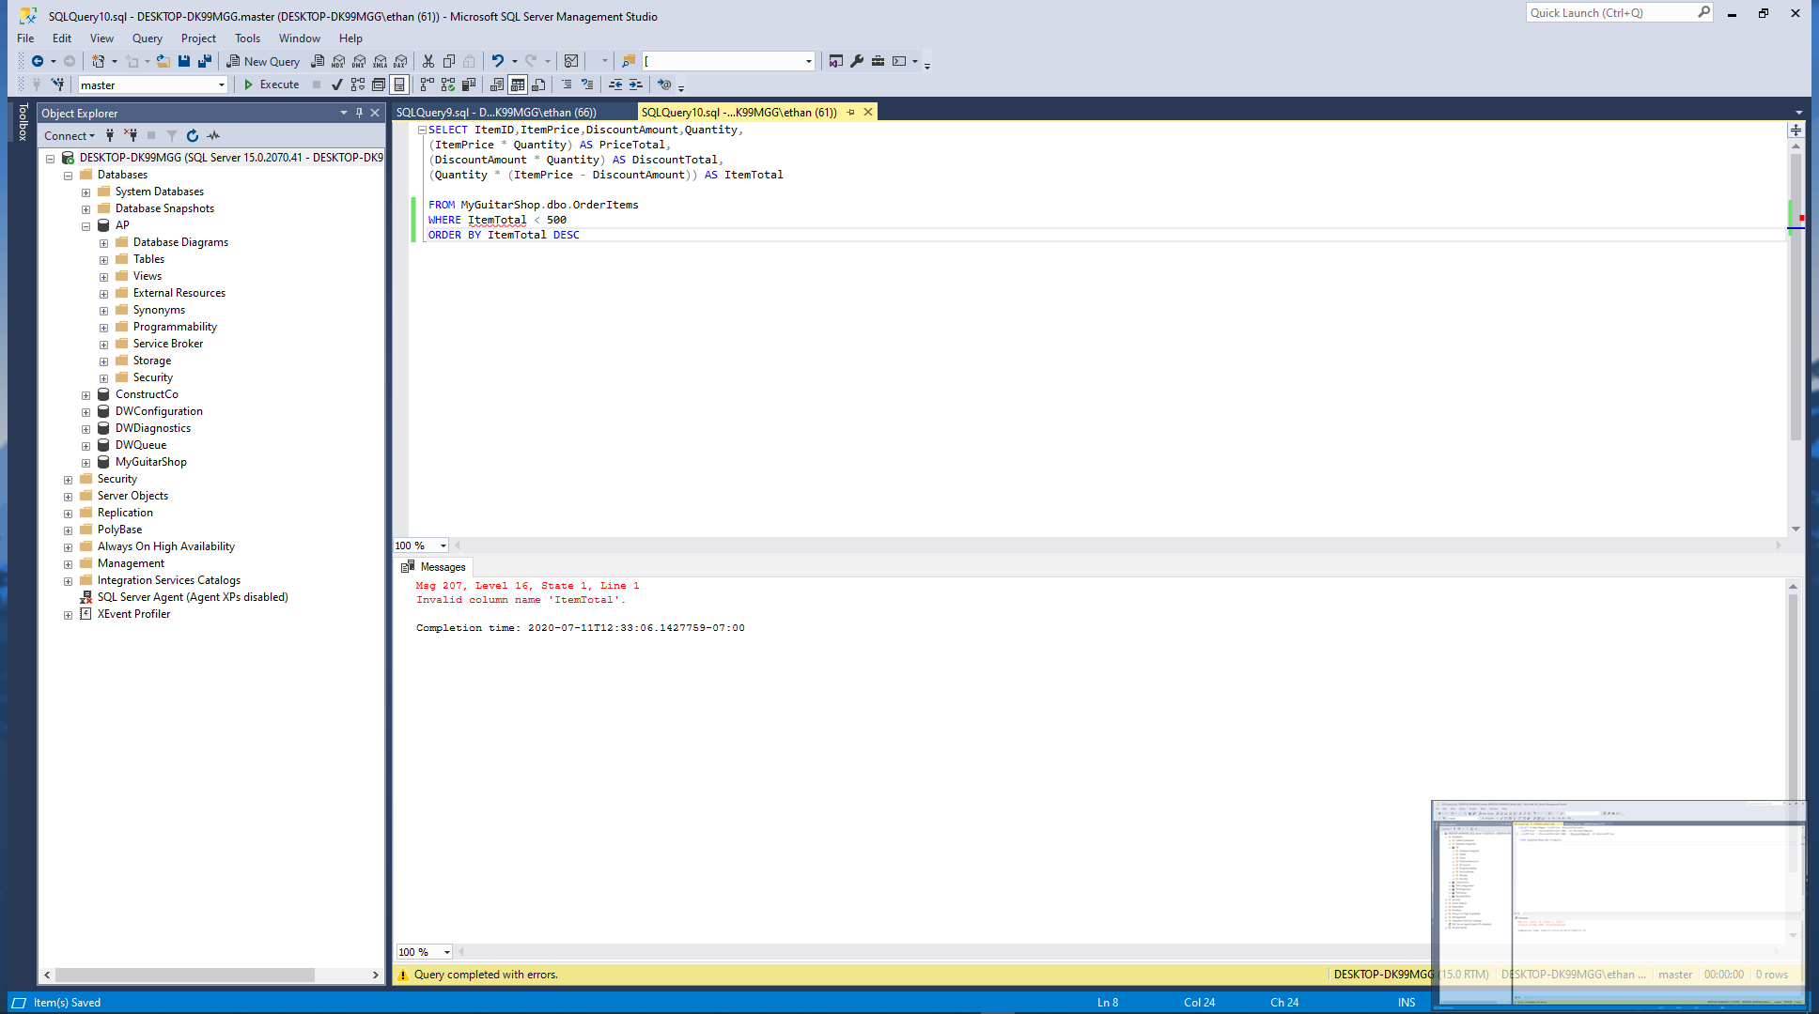

CANT GET IT TO WORK

Work with nulls and test expressions

1. Write a SELECT statement that returns these columns from the Orders table:

OrderID The OrderID column

OrderDate The OrderDate column

ShipDate The ShipDate column

Return only the rows where the ShipDate column contains a null value.

Paste a screen print of the SQL statement and the resulting data set below.



1. Write a SELECT statement without a FROM clause that creates a row with these columns:

Price 100 (dollars)

TaxRate .07 (7 percent)

TaxAmount The price multiplied by the tax

Total The price plus tax

To calculate the fourth column, add the expressions you used for the first and third columns.

Paste a screen print of the SQL statement and the resulting data set below.



Complete Chapter 7 Problems 1, 2 (*Note: Question will ask you to insert first two rows. You will NEED to insert ALL 9 rows to be able to complete the rest of the questions*), 3, 8, 9, 10, 15 Pg. 307-310 from Cengage

For these problems, you’ll enter and run your SQL statements. In addition to providing screen prints, create a SQL script file that contains your SQL statements. Once you’ve completed this lab, zip this Word document with your answers and your script file and upload the zipped file to the designated link in Canvas.

For these exercises number and answer below. Use red font when answering your question.

Number each problem and paste a screen print of the SQL statement and the resulting data set.

1. (Shown on 2 pic)

2.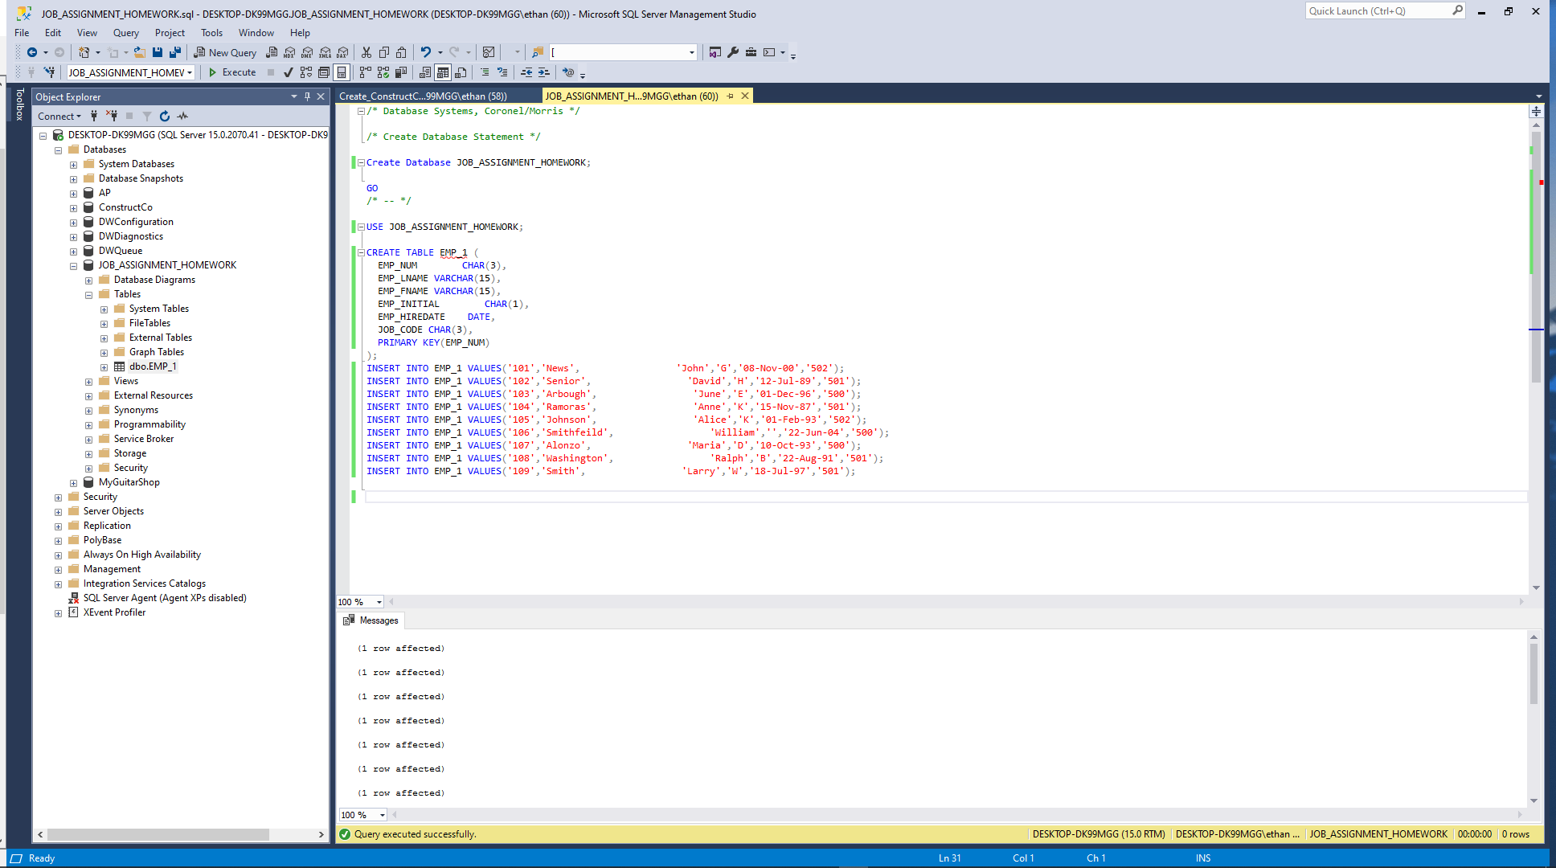

3. 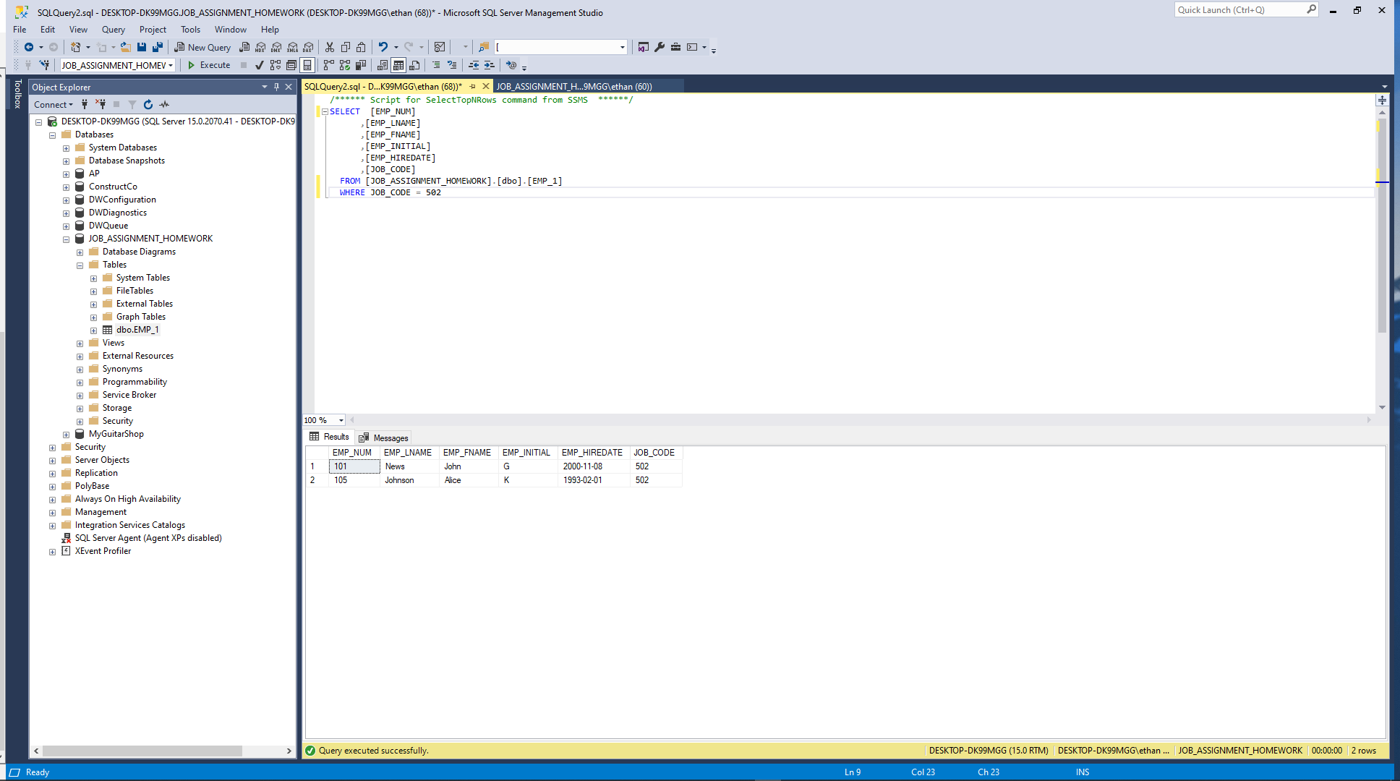

8. 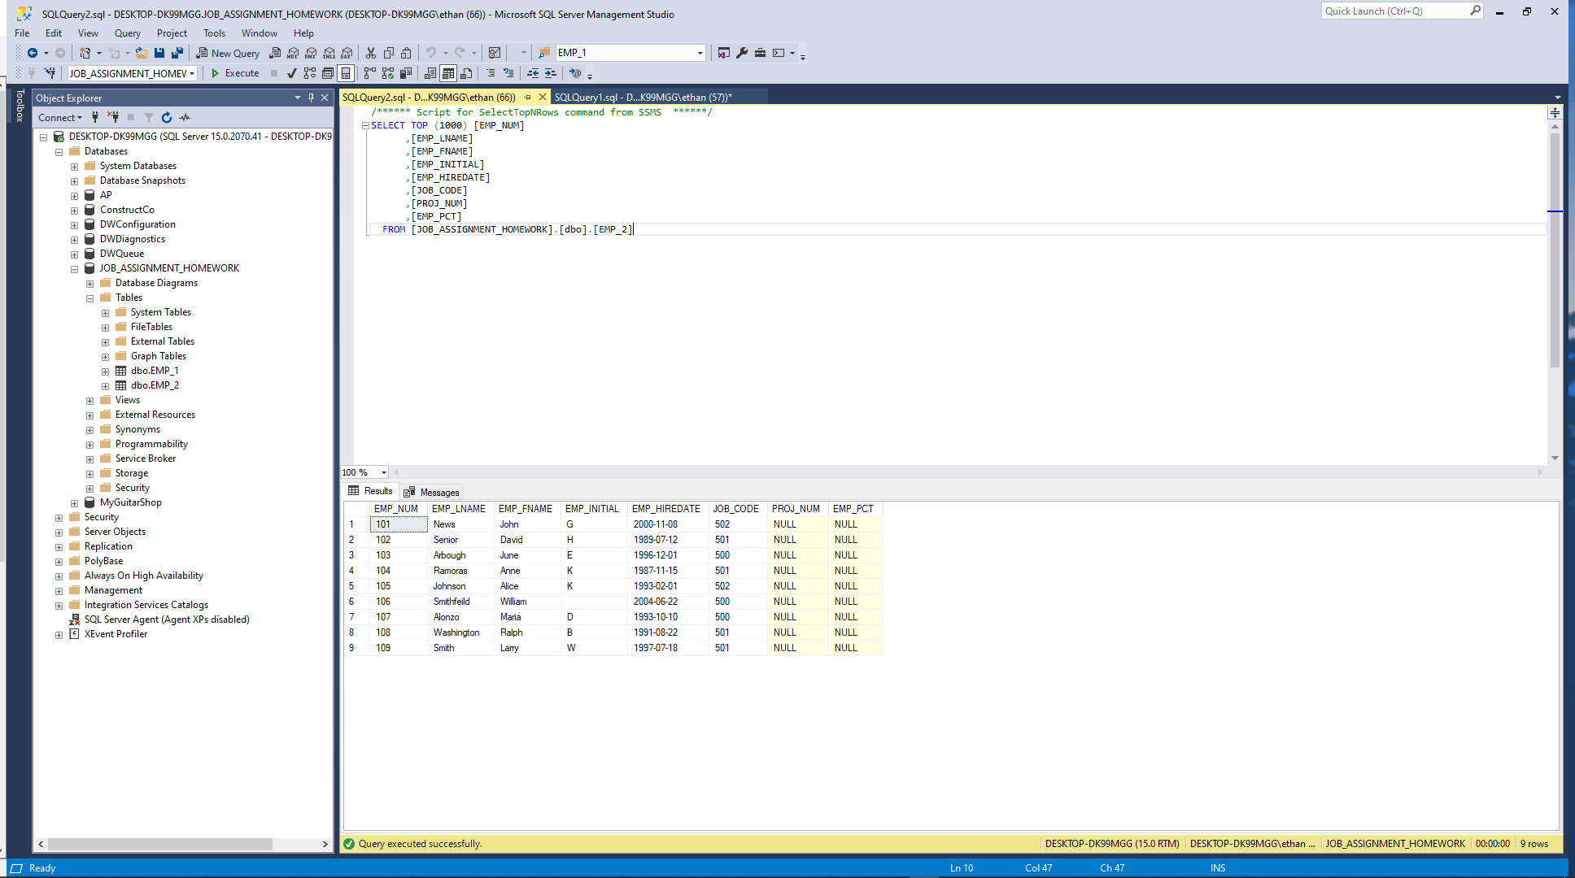

9. NOT SURE WHY THIS ISNT WORKING

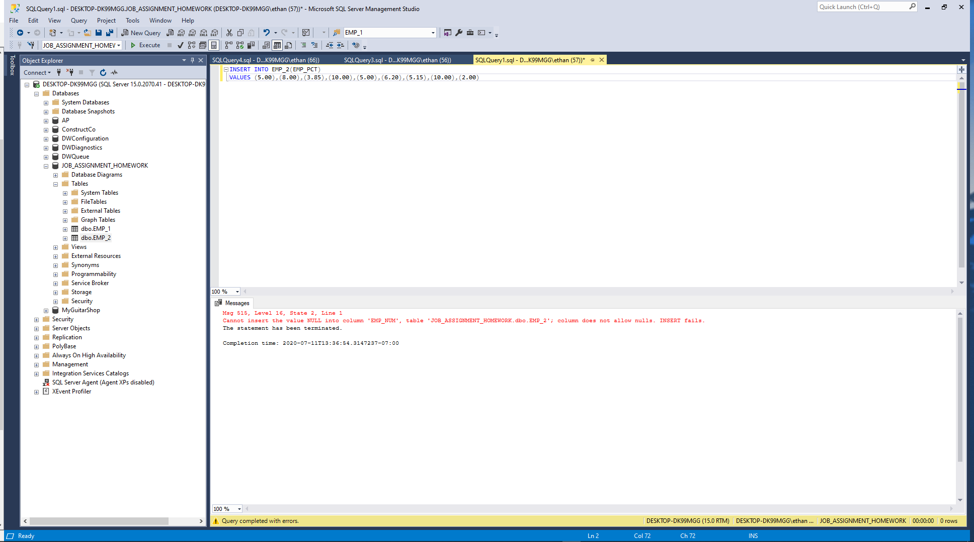

10. PLEASE SEND ME THE CODE SO I CAN UNDERSTAND WHAT I AM DOING WRONG

15

When you are finished zip this Word document with your answers AND your script files and then upload the zip file to the designated link in Canvas.